How to remove leading and trailing lines in the flat file with datastage

**Problem.**

The flat file has leading and trailing lines that are not part of the table. In the example below, we would like to skip the first line ‘Record of Employees’ and the last line ‘End of the file…’

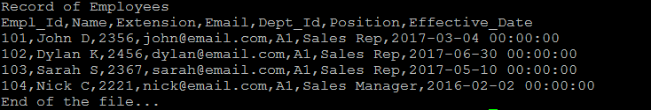

**Output**

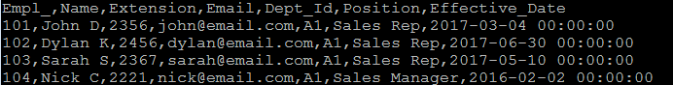

Solution

In the input with the Sequencial File Stage, use Filter option. In the filter, you can call Linux command. In this case use set ‘1d;$d’ to remove header and trailing line.

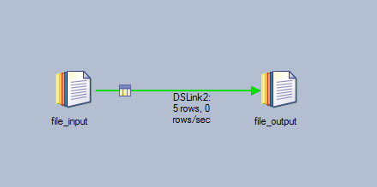

Source

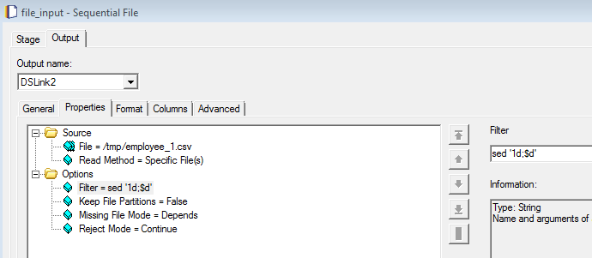

Output

